2019 SOITC International Rally “Pre-Rally Event”

SOITC has arranged a Pre-Rally Event at the Blue Gate Restaurant and Theatre in Shipshewana, Indiana!
(For our new Rally attendees or those not familiar with the Blue Gate Restaurant and Theater, please visit the following web site for information about offerings at the Blue Gate)

https://www.riegsecker.com

Date of Event:​​ Saturday, June 22, 2019

Dinner:​​ Family Style All You Can Eat​​ Time: 11:00 AM
Show:​​​ Simple Sanctuary ShowTime: 1:00PM
Cost:​​​ $55.95 per person (includes meal, show, gratuity and taxes)

We will be giving away 2 free Dinners and 2 theater tickets to 4 lucky Winners!!!
(SOITC will refund the purchase price)

Please Note:
You will need to allow at least 1 hour to get from Elkhart Campground to the Blue Gate Restaurant

Simple Sanctuary:

Based on the novel by Beverly and David Lewis, acclaimed Authors of Best selling Amish Novels,
Comes the story of Melissa James... She prayed the day would never come, but when her past comes calling, She has no choice but to flee. Pursued and living on the run, she finds desperate sanctuary in Amish country. Part suspense, part romance, Sanctuary is a compelling story of revenge, the price of freedom, and the solace found in the sanctuary of true community.

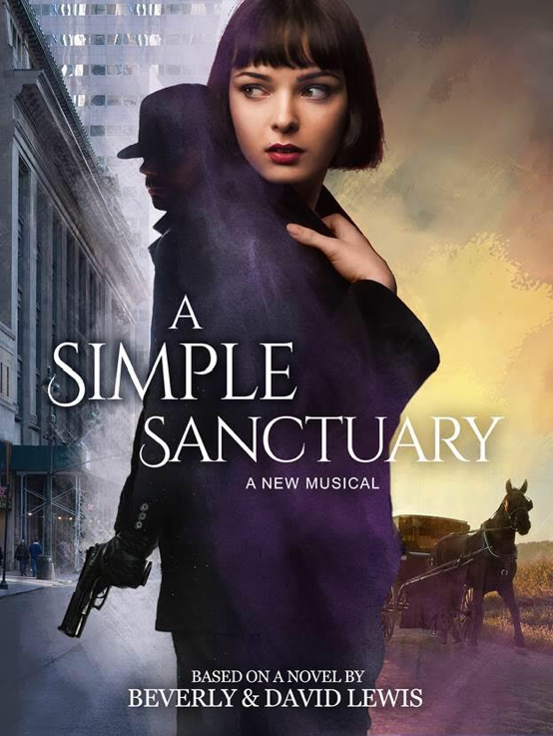
Reservations Due by May 1, 2019 ​​​

Name ________________________________________________ ​ $55.95

Name ________________________________________________ ​ $55.95
​​​​​​​
Total: _________________

Contact Information phone

__________________________________________

Contact Information email

___________________________________________
(Note: we do not share any contact information)

Make checks payable to Suites Owners International Travel Club

Forward Checks and reservation form / information (due by May 1, 2019) to:

Paul/Margie McClellan
PO Box 589
Huntington, IN. 46750

If you need further information please contact Paul McClellan 260-224-8642

